Opportunity Culture School Design Map
Opportunity Culture (OC) schools on average are far more likely to exceed growth goals for students, and far less likely to fall short of growth goals, than comparable schools.¹ This map will help your school choose Opportunity Culture roles and implement them in the right grades and subjects to achieve student and teacher success like high-growth Opportunity Culture schools. These schools aim for “Excellence for All”: high growth and advanced thinking skills for all students, allowing them to close gaps, improve their thinking skills, and leap ahead.
What school model should your school use, and how fast should you implement? Use the questions on the next page, which are based on data about designs used by high-growth Opportunity Culture schools. Factors affecting design include:
Note: We regularly update our resources, so this document is no longer available. Please visit the following webpage for more up-to-date resources: https://www.opportunityculture.org/opportunity-culture-director/
✱ Your school’s students, including poverty level, learning growth, and achievement gaps
✱ Your current teachers, including your supply of already excellent teachers
✱ Your school’s recruiting location and access to a strong hiring pool
✱ Funding for sustainable advanced-role stipends schoolwide
The map recommends that schools use these designs for high growth:
✱ Use Multi-Classroom Leadership schoolwide in most schools: All high-poverty schools and some low/moderate-poverty schools—those with typical or low percentages of high-growth teachers or persistent schoolwide achievement gaps—should use Multi-Classroom Leadership schoolwide as soon as feasible.
✱ Some schools can focus Opportunity Culture roles just on weak grades or subjects: This applies to low/moderate-poverty schools with high percentages of high-growth teachers and only one or two weak grades or subjects; and to other schools during the first years transitioning to Opportunity Culture models.
✱Multi-classroom leaders (MCLs) alone or alongside advanced-role, direct-reach teachers (blended-learning teachers, elementary specialists, or expanded-impact teachers—“combos” when combined with MCLs) appear to be equally effective. Multiple roles and advancement levels also provide career options and may improve recruitment and retention.
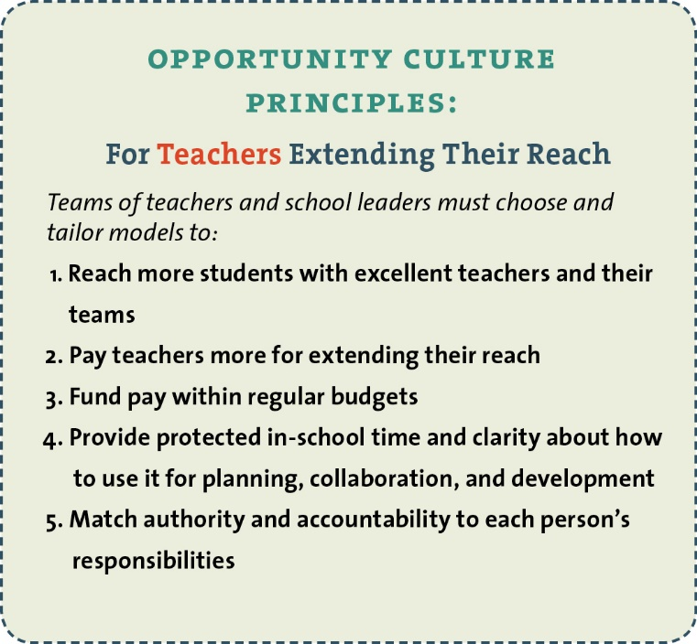
Use hard data about student poverty, achievement, and growth, where possible, and teacher excellence (with other measures in your teacher evaluation system).
Keep your school designs and implementation within the five Opportunity Culture Principles (at right), which data indicate affect outcomes and sustainability. Design details and implementation also will affect your outcomes. Your Public Impact facilitator will guide you.
Free materials on OpportunityCulture.org can also help your teachers and principal.

______________________________________________
¹ In tested grades and subjects where comparable data are available. See our dashboard.

