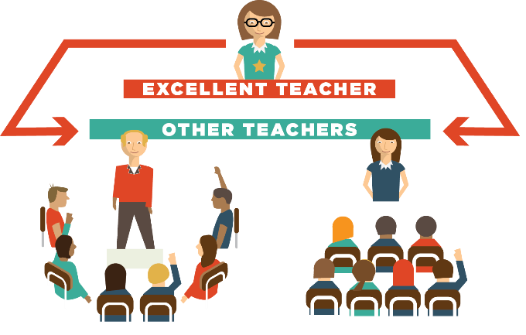
Multi-Classroom Leadership

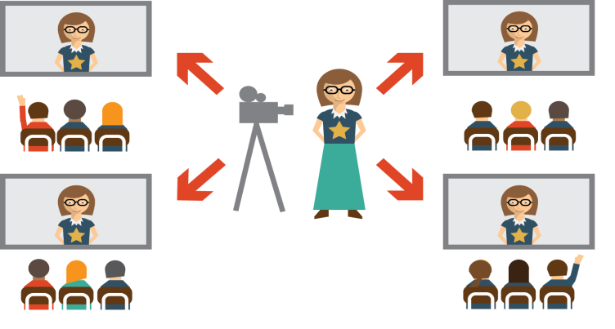
Remote Teaching

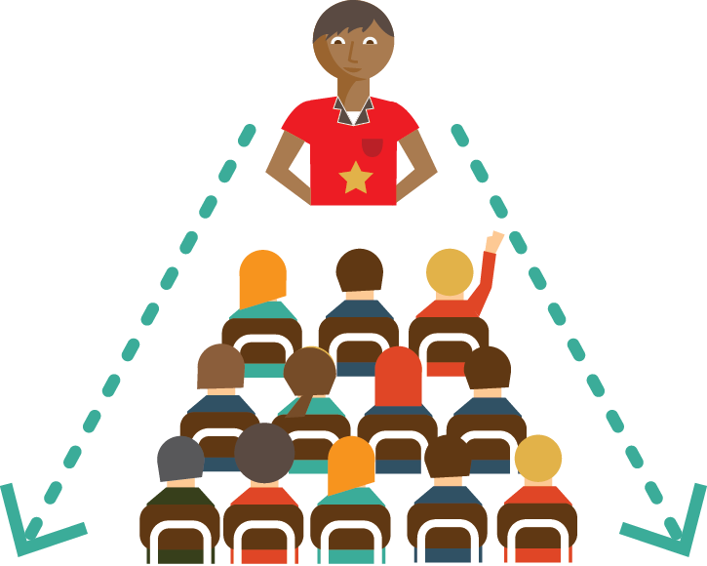
Class-Size Increase

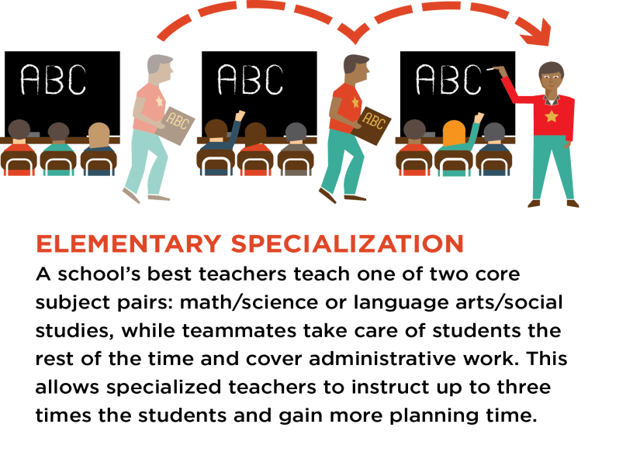
Specialization

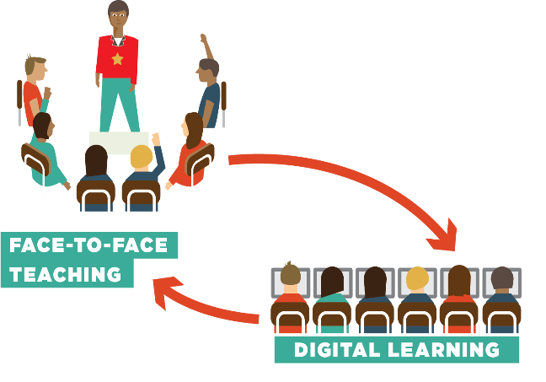
Time-Technology Swap

MCL Answers

Reaches more students with excellent teaching, both directly and indirectly.

Teacher-leader determines how students spend time.

Teacher-leader tailors team teacher roles according to their strengths.

Accountable for results of own students and students taught by team teachers.

May be supported by a Reach Associate.

Teacher spends part of time teaching students directly and part of time supporting other adults.

Time-Tech Swaps Answers

Students alternate between learning from the excellent teaching and digital learning.

Students spend part of the day engaged in age- and child-appropriate digital learning.
May use in-person rotation where the same groups of students rotate on a fixed schedule between learning with a teacher and learning through digital instruction.

May use an in-person flex schedule where excellent teachers pull out students in frequently changing, flexible groups for small group instruction.

May be supported by a Reach Associate.

Reach more students directly with excellent teaching.

Class-Size Increase Answers

Reach more students with excellent teaching directly.

Teacher chooses to teach larger classes (within limits).

Few OC schools choose to use this model without combining with another OC model.

Specialization Answers

Reaches more students directly with excellent teaching.

Elementary-specific model.

Teachers specialize in one or two subjects of expertise.

May be supported by a Reach Associate.

Remote Teaching Answers

Reaches more students directly with excellent teaching.

Teacher is not always in the same location as his/her students.

This model is particularly useful in subjects where there is a major shortage of qualified teachers (often STEM subjects, often in more isolated districts).

Supported by a Reach Associate.

Students alternate between learning from the excellent teacher and digital learning.

This model can bring an excellent Physics teacher who lives in Syracuse to students who live in rural school districts across the state.

